Spotting a Medical Emergency: Signs, Symptoms, and What to Do- H1
Author : Dr. Roop Sai Krishna Yadav, Accident and Emergency department

Priority | Search Volume | Keyword Intent | ASV
P1 | Medical Emergency | Informational | 5400
P1 | Emergency Symptoms | Informational | 10
P1 | Recognizing Emergencies | Informational | 10
P2 | Medical Emergency Signs | Informational | 20

Title- Medical Emergency Guide: Signs and Symptoms to Know
Description- Recognize a medical emergency symptoms like chest pain, difficulty breathing, severe bleeding, or sudden confusion need immediate attention.
Slug- /what-is-medical-emergency
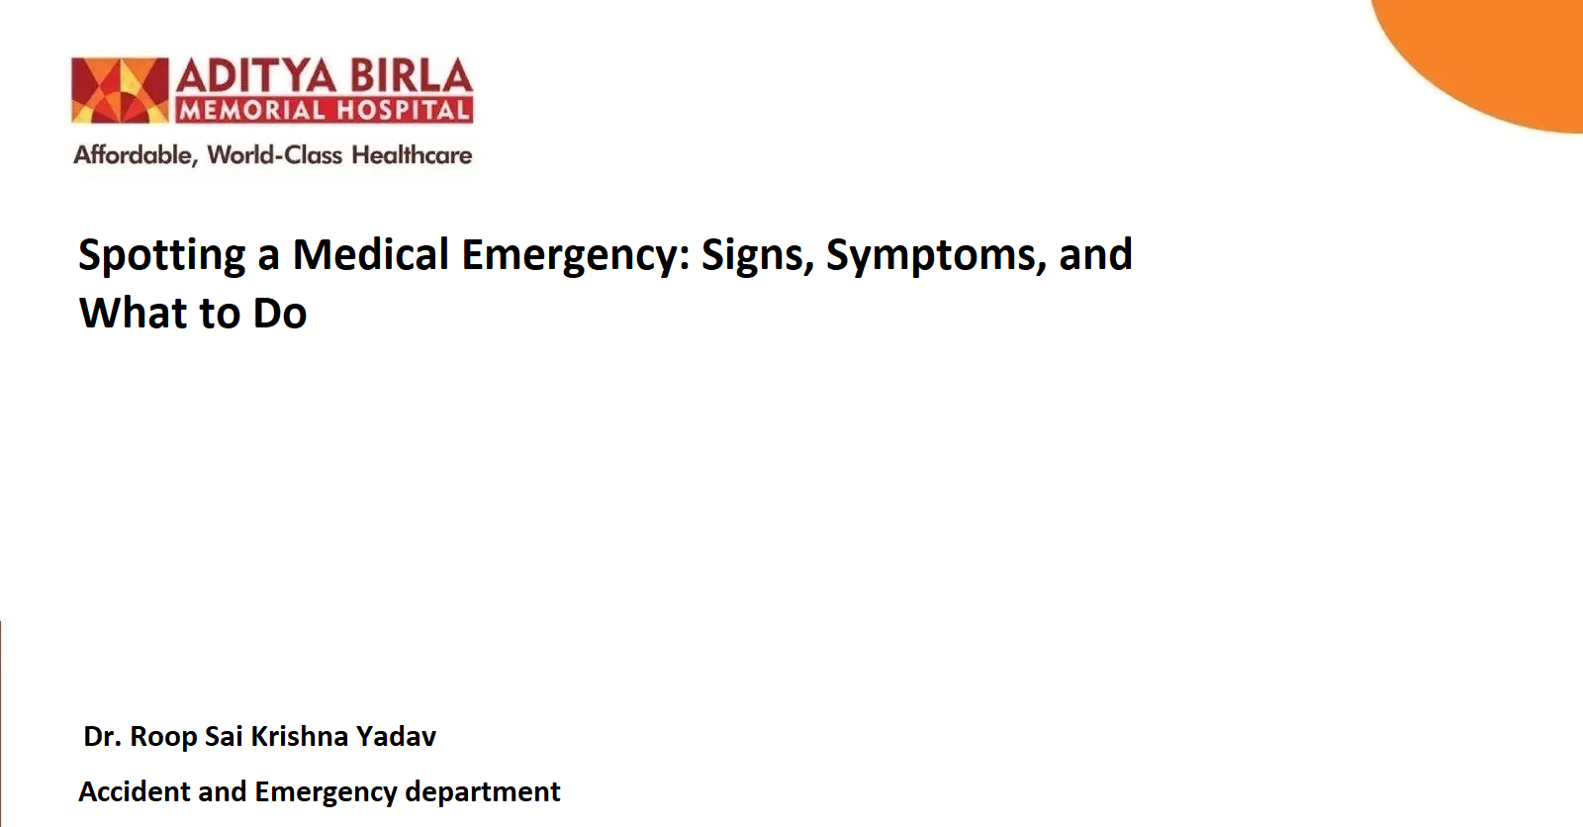
Medical emergencies can occur unexpectedly, turning ordinary moments into critical situations that demand immediate action. Knowing how to recognize medical emergencies and respond promptly can save lives.
This guide explains how to identify emergency symptoms, prepare for such events, and take the right steps when faced with a medical emergency.

What Is a Medical Emergency?-H2
Any situation that puts a person's health, life, or overall well-being at serious risk, is called a medical emergency. These scenarios often require urgent medical intervention to prevent serious complications, permanent damage, or death.
Emergencies vary widely, from sudden illnesses to traumatic injuries, but they all share the characteristic of needing swift and decisive action.

Recognizing Emergencies: The Warning Signs-H2
The first step in effectively handling a medical emergency is understanding its warning signs. Below are some of the most common emergency symptoms to watch for:

1. Chest Pain or Pressure-H3
- Pain or discomfort in the chest, especially if it spreads to the arms, neck, jaw, or back, could indicate a heart attack.
- This type of pain is often described as a squeezing or pressing sensation.

2. Difficulty Breathing-H3
Struggling to catch your breath, rapid breathing, or gasping for air can signal a respiratory issue like an asthma attack or a severe lung infection.

3. Loss of Consciousness-H3
Fainting, confusion, or sudden unresponsiveness may point to conditions such as a stroke, head injury, or severe dehydration.

4. Severe Bleeding-H3
- Heavy, uncontrolled bleeding, particularly from a major artery or organ, requires immediate attention.
- Apply firm pressure on the wound while waiting for medical assistance.

5. Sudden, Severe Headache-H3
A headache that strikes suddenly and is unusually intense may indicate a stroke, brain haemorrhage, or other neurological conditions.

6. Seizures-H3
- Sudden, uncontrollable jerking movements or loss of consciousness may signify a seizure.
- Clear the area of sharp objects and avoid restraining the person.

7. Severe Allergic Reaction-H3
Symptoms include swelling of the face or throat, difficulty breathing, and hives. These are indicators of anaphylaxis, a life-threatening condition.

8. Severe Abdominal Pain-H3
Persistent, sharp pain in the abdomen can signal appendicitis, pancreatitis, or other serious conditions requiring immediate evaluation.

How to Prepare for a Medical Emergency-H2
Preparation is key to managing medical emergencies effectively. Here’s how you can stay ready:

1. Learn Basic First Aid and CPR-H3
- Knowledge of first aid and CPR can save lives in situations like cardiac arrest or choking.
- Many organizations offer certification courses that equip you with these essential skills.

2. Keep Emergency Numbers Accessible-H3
Make sure emergency contacts, including local ambulance services and poison control, are stored in your phone and displayed in visible areas at home.

3. Maintain a First Aid Kit-H3
- Stock your kit with bandages, antiseptics, pain relievers, and prescription medications.
- Include a flashlight and emergency phone charger as well.

4. Use Medical Alert Systems-H3
Devices like bracelets or pendants can notify emergency responders about pre-existing conditions or allergies.

5. Stay Updated on Emergency Procedures-H3
Regularly refresh your knowledge of first aid and emergency response guidelines.

What to Do During a Medical Emergency-H2
When faced with a medical emergency, quick thinking and decisive action are essential. Follow these steps:

Step 1: Stay Calm and Assess the Situation-H3
Take a deep breath and evaluate what’s happening. Determine if the person is breathing, conscious, or bleeding.

Step 2: Call for Help-H3
Dial 108 and provide clear information about the location, nature of the emergency, and the individual’s condition.

Step 3: Administer Basic First Aid-H3
- For bleeding: Apply pressure with a clean cloth to stop it.
- For unconsciousness: Place the person in the recovery position (on their side).
- For choking: Perform the Heimlich manoeuvre if trained.

Step 4: Monitor the Person’s Condition-H3
Keep an eye on vital signs like breathing, pulse, and consciousness. Be ready to provide updates to emergency responders.

Step 5: Prepare for Emergency Personnel-H3
Clear a path for the medical team and gather any relevant medical information, such as allergies or current medications.

When to See a Doctor or Call Emergency Services-H2
Knowing when to seek professional help is vital. Call for emergency assistance if any of the following emergency symptoms occur:
- Persistent chest pain or discomfort.
- Difficulty breathing or choking.
- Severe, uncontrolled bleeding.
- Sudden loss of consciousness or confusion.
- Suspected heart attack or stroke symptoms.
- Seizures lasting more than five minutes or occurring repeatedly.
- Severe allergic reactions, including swelling of the face or throat.
If you're ever uncertain about whether a situation qualifies as a medical emergency, it’s better to err on the side of caution and call for help.

Common Mistakes to Avoid During Emergencies-H2
- Delaying Action: Hesitation can worsen the condition. Respond immediately.
- Neglecting Personal Safety: Ensure you’re not putting yourself at risk while helping others.
- Administering Incorrect Aid: Avoid attempting procedures you’re not trained for, as they could cause more harm.

Importance of Recognizing Emergencies-H2
The ability to recognize the signs of a medical emergency is not just for doctors; it’s a skill everyone should have. Early intervention can significantly improve outcomes, reducing the risk of complications or fatalities.
By staying informed and prepared, you empower yourself to handle these situations confidently and effectively.

Conclusion-H2
A medical emergency can happen to anyone, anywhere, at any time. Recognizing the emergency symptoms and knowing how to respond promptly are vital skills that can save lives. From understanding the warning signs to preparing for emergencies and acting decisively, every step you take matters.
If you are in the Pimpri-Chinchwad area, feel free to call or visit Aditya Birla Memorial Hospital for expert emergency care.
Reference:H2
CDC. About heart attack symptoms, risk, and recovery [Internet]. Heart Disease. 2024 [cited 2024 Nov 18]. Available from: https://www.cdc.gov/heart-disease/about/heart-attack.html
CDC. About [Internet]. Asthma. 2024 [cited 2024 Nov 18]. Available from: https://www.cdc.gov/asthma/about/index.html
Symptoms [Internet]. NHLBI, NIH. [cited 2024 Nov 18]. Available from: https://www.nhlbi.nih.gov/health/stroke/symptoms
Powell MR, McCrea M. Traumatic brain injury (TBI). The Wiley Encyclopedia of Health Psychology [Internet]. 2020 [cited 2024 Nov 18]; Available from: https://www.ninds.nih.gov/health-information/disorders/traumatic-brain-injury-tbi
Miller E. Headache. Journal of Neurology, Neurosurgery & Psychiatry [Internet]. 1980 [cited 2024 Nov 18];43:1050–1050. Available from: https://www.ninds.nih.gov/health-information/disorders/headache

